Tips and Tricks in Working With Tables, Line and Paragraph Spacing in Microsoft Word

To convert existing text to a table:
- Select the text you wish to convert.
- Select the Insert tab.
- Click the Table command.
- Select Convert Text to Table from the menu. A dialog box will appear.
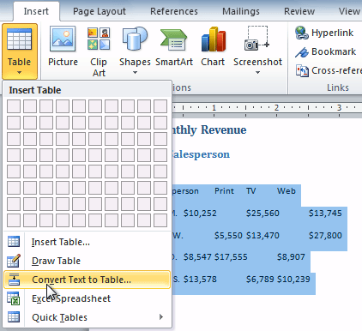
- Choose one of the options in the Separate text at: section. This is how Word knows what text to put in each column.
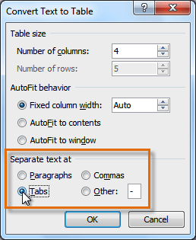
- Click OK. The text appears in a table.
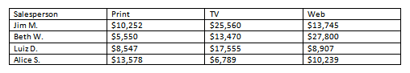
To apply a table style:
- Click anywhere on the table. The Design tab will appear on the Ribbon.
- Select the Design tab and locate the Table Styles.
- Click the More drop-down arrow to see all of the table styles.
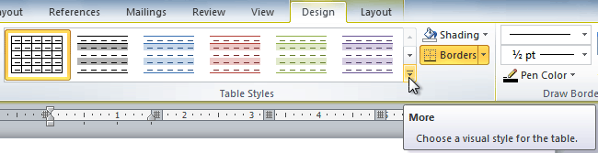
- Hover the mouse over the various styles to see a live preview.
- Select the desired style. The table style will appear in the document.
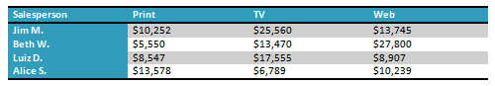

To change the table style options:
Once you've chosen a table style, you can turn various options on or off to change the appearance of the table. There are six options: Header Row, Total Row, Banded Rows, First Column, Last Column, and Banded Columns.
- Click anywhere on the table. The Design tab will appear.
- From the Design tab, check or uncheck the desired options in the Table Style Options group.
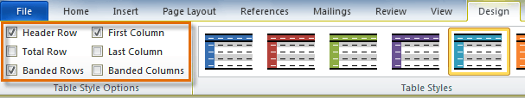
Depending on which Table Style you're using, certain Table Style Options may have a somewhat different effect. You may need to experiment to get the exact look you want.

About line spacing
Line spacing can either be measured in lines or points. For example, when text is double-spaced, the line spacing is two lines high. On the other hand, you might set 12-point text with something like 15-point spacing, which gives enough height for the text plus a little extra space. You can reduce the line spacing to fit more lines on the page, or you can increase it to improve readability.
Line spacing is also known as leading (pronounced to rhyme with "wedding").

To format line spacing:
- Select the text you want to format.
- Click the Line and Paragraph Spacing command in the Paragraph group on the Home tab.
- Select the desired spacing option from the drop-down menu.
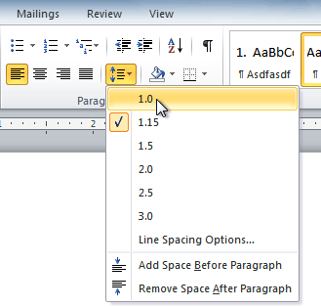
- From the drop-down menu, you can also select Line Spacing Options to open the Paragraph dialog box. From here, you can adjust the line spacing with even more precision.
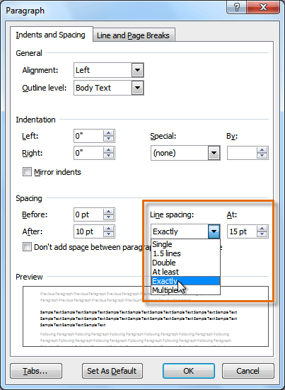
If you select At least or Exactly in the Paragraph dialog box, the line spacing will be measured in points. Otherwise, it will be measured in lines.
Paragraph spacing
Just as you can format spacing between lines in your document, you can choose spacing options between each paragraph. Typically, extra spaces are added between paragraphs, headings, or subheadings. Extra spacing between paragraphs helps to make a document easier to read.

To format paragraph spacing
- Click the Line and Paragraph Spacing command on the Home tab.
- Select Add Space Before Paragraph or Remove Space After Paragraph from the drop-down menu.
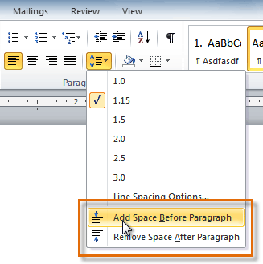
- From the drop-down menu, you can also select Line Spacing Options to open the Paragraph dialog box. From here, you can control exactly how much space there is before and after the paragraph.
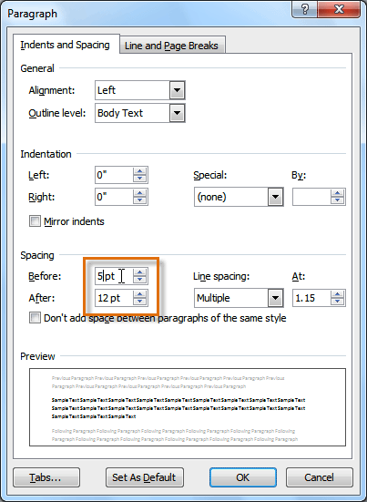
You can use Word's convenient Set as Default feature to save all of the formatting changes you've made and automatically apply them to new documents.

