Learning to Use Google Drive
Google Drive allows an individual to store documents online, share them with others and even invite colleagues to collaborate on a shared document, spreadsheet, form, or presentation. You can each edit online and in real time. When a Google document is edited the document is automatically saved and stored, and a history of the change is kept. An on-screen chat window shows who else is online viewing the documents. Google Drive is also available as an app for multiple platforms.
Google Drive also lets you save in a variety of formats, including: DOC, XLS, CSV, ODS, ODT, PDF, RTF and HTML. In addition, you can also import files from Microsoft Office or other applications for collaboration.
Once you have created your Google account you are now ready to get started using it. Click on the following icon to access Google Drive
Click here

Click the Drive App

Click Create--Users are able to create documents, PowerPoint presentations, spreadsheets, forms, and use the drawing program. Users can also allow others to access and share documents.

When the document is created you have to name the document and click Share as indicated below:

A new dialog box will appear for you to Invite People to share the document with by typing in their email addresses. Once all addresses have been inserted click Done. Those individuals that you selected to share the document with will have access to edit information that has been shared.

Type in the email address of those individuals you wish to share this document with.

Sorting, Filtering, and Searching
Google Drive uses three main tools to help you locate your files: sorting, filtering, and searching.
  - Sorting your files lets you put them in order. By default, your files are already sorted from newest to oldest. However, you can apply other sorts to put your docs in alphabetical order or order them from largest file size to smallest.
  - Filtering your files lets you hide unimportant files and focus only on the ones you're interested in. For example, if you were looking for a presentation, you could use a filter to narrow down your visible files so that you would only see the presentations.
  - Searching lets you look for specific files using words contained within the file.

Organizing Files
Once you start placing a lot of files onto your Google Drive, you can use folders to help organize and group your files. Folders in Google Drive work just like the folders on your computer. In addition, Google Drive makes creating and managing your folders easy.

To Create a Folder:
While viewing your Google Drive, click the Create button and then select Folder from the drop-down menu.
Folders can be renamed and color added to them

The File Action Buttons
The file action buttons will appear at the top of your Google Drive whenever you select a file. As we have already seen, you can use the Organize button to manage your files. But the file action buttons also provide powerful shortcuts that will help you manage your files in different ways.
- Click the Trash button to move a file to the Trash folder, which is like the Windows Recycle Bin.
- Click the Preview button to see a quick preview of a file without opening it.
- Click the More button to Add a Star to a file, rename a file, or mark a fileas unviewed. You can also access the other file actions from the More button.

To Delete a File:
Deleting a file from your Google Drive is very similar to deleting a file from your computer. You will have to move the file to the trash folder and then delete it permanently, like deleting a file from the Recycle or Trash Bin on your computer.
- While viewing your Google Drive, select the file you wish to delete.
- The file action buttons will appear. Click the Trash button to move the file to the trash folder.
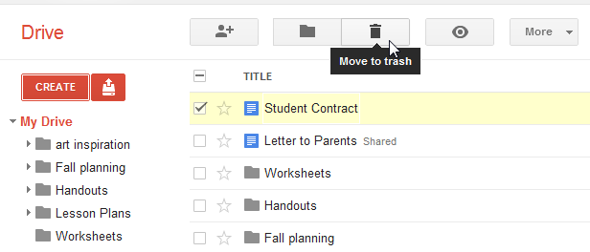Moving a file to the trash folder

This is an excellent source to use in helping you better understand how to effectively use Google Drive components: http://www.gcflearnfree.org/googledriveanddocs. Step-by-step directions with examples are provided along with a tutorial video.

