How to Create a Table of Contents in Microsoft Word
by BILL • AUGUST 14, 2013

Imagine that you’re working with a really long document in Microsoft Word, like an academic paper or a big report. Depending on the project, it might be dozens or even hundreds of pages long! When a document is this big, it can be hard to remember which page has what information. Fortunately, Word allows you to insert a table of contents, making it easy to organize and navigate your document.
A table of contents is just like the list of chapters at the beginning of a book. It lists each section in the document and the page number where that section begins. A really basic table of contents might look like this:
You could create a table of contents manually, typing the section names and page numbers, but it would take a lot of work. And if you ever decide to rearrange your sections or add more information, you’ll have to update everything all over again. However, with the right formatting, Word can create and update a table of contents automatically.
We’ll use Word 2013 to show you how to create a table of contents, but you can use the exact same method in Word 2010 or Word 2007.

Step 1: Apply Heading Styles
If you’ve already read our lesson on Styles, you know that they’re an easy way to add professional text formatting to different parts of your document. But styles also serve another important purpose: adding a hidden layer of organization and structure to your document.
If you apply a heading style, you’re telling Word that you’ve started a new part of your document. When you insert the table of contents, it will create a section for each heading. In the table of contents above, each chapter uses a heading style, so there are four different sections.
To apply a heading style, select the text you want to format, then choose the desired heading in the Styles group on the Home tab.
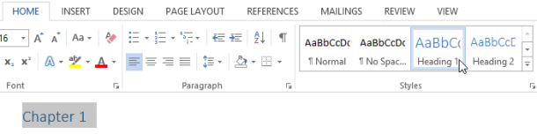

Step 2: Insert the Table of Contents
Now for the easy part! Once you’ve applied heading styles, you can insert your table of contents in just a few clicks. Navigate to the References tab on the Ribbon, then click the Table of Contents command. Select a built-in table from the menu that appears and the table of contents will appear in your document.
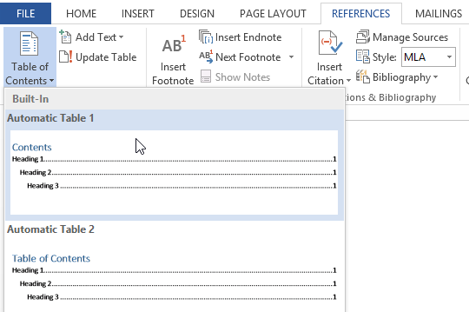
As you can see in the image below, the table of contents uses the heading styles in your document to determine where each section begins. Sections that begin with a Heading 2 or Heading 3 style will be nested within a Heading 1 style, much like a multilevel list.
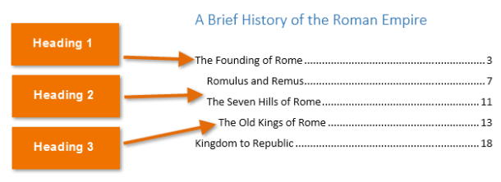
A Table of Contents also creates links for each section, allowing you to navigate to different parts of your document. Just hold the Ctrl key on your keyboard and click to go to any section.

Step 3: Update as Needed
If you edit or add to your document, it’s easy to update the table of contents. Just select the table of contents, click Update Table, and then choose Update Entire Table in the dialog box that appears. The table of contents will then update to reflect any changes.
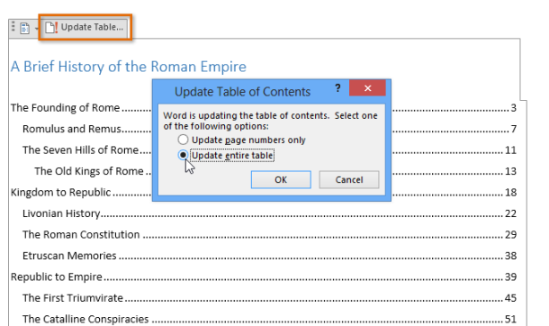
No matter how big your document, you can see there’s nothing complicated about creating a table of contents.

